State of Louisiana
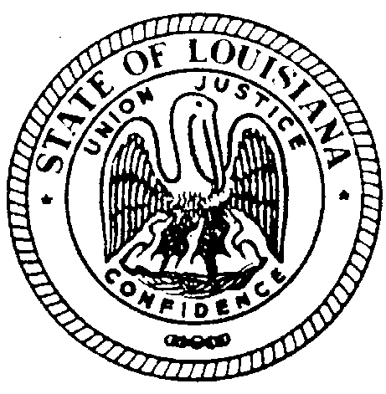
THE LOUISIANA BOARD FOR HEARING AID DEALERS

MINUTES OF MEETING
July 29, 2022
EMBASSY SUITES CONGRESS ROOM BATON ROUGE, LOUISIANA

The Louisiana Board for Hearing Aid Dealers Meeting was called to order at 1:00pm on
July 29, 2022 held at the Embassy Suites Congress Room Baton Rouge, LA by Chairman Jeremy Stroud.

Visitor(s): NONE

- CALL TO ORDER:
Those present were Jana Broussard, Jeremy Stroud, Jason Shevchuk, Alisea Cormier & Bryan Stinson. Quorum was met. Dina Zeevi, the Board’s Administrative Secretary was present to take the minutes of the meeting.

PUBLIC COMMENTS- NONE

- APPROVAL OF AGENDA
Alisea Cormier makes a motion to accept the meeting agenda. Motion 2nd. Approved Unanimously.

- READING/APPROVAL OF MINUTES January 22, 2022
Minutes of the meeting were presented to the Board in form of an advanced email. Bryan Stinson made a motion to accept the minutes; the motion was seconded. All in favor, approved unanimously.

- Secretary/Treasurer’s Report
Jason Shevchuk made a motion to table the report. Motion 2nd. Approved Unanimously.

- A) Ethics Review Complaint #119 Cash vs. Miracle Ear/Stuart
Ethics Chair Bryan Stinson recommend to LABHAD complaint be closed. No statute violations. Alisea Cormier made a motion to accept the Ethics Committee’s recommendation. Motion 2nd. Approved Unanimously.
B) Examination Committee
4 Practical Examinations- 4 Passed
4 Open Book Examinations- 4 Passed
2 Written Examinations- 2 Passed
2 Applicants waiting on Written Examination Results
C) Legislative Committee:
Statute Revision change in effect RE: statute eliminating license requirement to repair hearing aids.
Corporate Form language to be submitted in January 2023 to the State of Louisiana to review the statute language.
TeleHealth Access Act language submitted to OLRC. Added to LABHAD’s Rules & Regulations. Approved by the OLRC Committee.

- UNFINISHED BUSINESS
None

- NEW BUSINESS
- Alisea Cormier made a motion to allow all CEs to be received online in 2022. Motion 2nd. Approved Unanimously
- Alisea Cormier made a motion for LABHAD Board Members to receive virtual CE credit for taking the State Required Online courses. Motion 2nd. Approved Unanimously.
- Alisea Cormier made a motion for LABHAD Board Members to receive in person CE credit for proctoring the Practical Exam. Motion 2nd. Approved Unanimously

Break 1:41pm-1:48pm

- ByLaws Article IX Representative of Ethics Committee- Language stands. No motion or change needed.
- Alisea Cormier made a motion to accept the additional language to VI ByLaws. Motion 2nd. Approved unanimously.
- Alisea Cormier made a motion to approve Application language revisions. Motion 2nd. Approved unanimously.
- Bryan Stinson made a motion to approve Virtual Office Inspections. Motion 2nd. Approved unanimously.
- Alisea Cormier made a motion to accept statute changes RE: Elderly Consumer language. Legislative Chair Jeremy Stroud will submit Statute Changes to state in January 2023 Motion 2nd. Approved unanimously.
DATE AND LOCATION OF NEXT 2023 MEETING/PRACTICAL EXAMINATION

Chairman Jeremy Stroud set next meeting/practical examination date and location:
Practical Examination DATE: Friday January 20, 2023 9am-12noon
Meeting DATE: Friday January 20, 2023 1:30pm-5:00pm
Location: Embassy Suited Baton Rouge, LA

Motion made by Jana Broussard to adjourn meeting, the motion was seconded. All in favor, approved unanimously.

Meeting adjourned at 2:39pm

